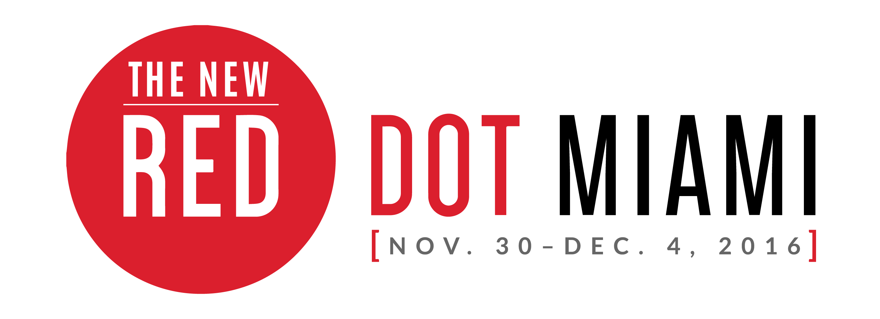

FOR IMMEDIATE RELEASE
Media Contact:
Jaclyn Walian
Olive PR Solutions, Inc.
m. 619-772-5602 o. 619-955-5285
jaclyn@oliveprsolutions.com

Red Dot Miami Announces 2016 Interactive Programming
-From South African art to an immersive art experience, Red Dot Miami’s 2016 programming will exceed expectations for Miami Art Week-

MIAMI (Nov. XX, 2016) – Red Dot Miami, a juried contemporary art show taking place Nov. 30 – Dec. 4 in the heart of the Arts and Entertainment District, announces its lineup of specially curated programs, including Art Labs, Art Talks, Spotlight Galleries and more. The abundance of trend-setting artists and galleries exhibiting at Red Dot Miami will reflect this year’s theme, [EVOLVE]: At every turn, the art world is shifting. Galleries, artists, and collectors alike are continuously evolving, in turn imploring us to expand our perspectives. Red Dot Miami is known for showcasing galleries representing primary and secondary market artists, showing art to inspire attendees from all over the world.

These programs provide a dynamic experience for attendees, allowing them to view and interact with works by leading national and international artists, and view exhibitions and events that showcase the thriving art landscape of Miami.

ART LABS
Art Labs feature specially curated site-specific projects by prominent Miami-based galleries, art institutions, and art collectives within the show. Major Art Labs this year include:

- SOUTH AFRICAN ART COLLECTIVE
Red Dot Miami is a stop on the national tour of the South African Art Collective. Sponsored by the South African Department of Small Business Development and its desire to support the creative industries through market access platforms, the South African Art Collective Art Lab showcases creative diversity, while supporting the goals of development and access in an expanded marketplace for the artists. The Collective's curator, Nkululeko Khumalo, is an artist and printmaker herself, and is traveling with the Collective. She is passionate about promoting the world of South African art—especially highlighting artists from disadvantaged communities.

- pARTicipate WITH LIFE IS ART
Art meets technology in pARTicipate, an immersive art experience melding virtual reality, visual art, music, film, and fashion. Join Life Is Art along with partners Virtual Relief and MIU as they create a unique and exciting experience where you can interact and become part of the art as well as create your own work of art through virtual reality technology.
SPOTLIGHT GALLERIES
Red Dot Miami’s Spotlight Gallery Program offers a focused look at several cutting-edge galleries. The galleries selected are Masterworks Fine Art from Oakland Hills, California; island6, from Shanghai, China; and Gallery Steiner from Vienna, Austria.

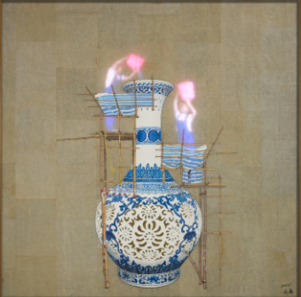
island6 – “And So We Made a Mess” by Liu Dao

TOP EVENTS NOT TO MISS
- Friday, December 2: ART TALK: DESIGN FRIDAY! DESIGNING A HOME FOR ART COLLECTORS
Join Robin Hodes and her prestigious panel as they discuss how to design your home for your style and your art collection. Join the discussion on color, room theme, public and private spaces, plus choosing the right space for each type of piece.

- Friday, December 2 and Saturday, December 3: DJ KEITH BUTLER
Enjoy the hottest tracks from New York's DJ Keith Butler while experiencing the excitement of Red Dot Miami's amazing art and events.

Tickets for Red Dot Miami’s Opening Night Preview Party are priced at $50. General Admission tickets are $75 for all five days or $25 for one day. Tickets will also grant you access to Spectrum Miami. A percentage of all ticket sales benefit LIFE is ART, a local Miami-based charity. For more information on Red Dot Miami, please visit www.reddotmiami.com.

###

SHOW HOURS:
Opening Night Preview Party: Wednesday, November 30, 2016 | 6 – 10pm

General Public Show Hours:
Thursday, December 1, 2016 | 12 – 8pm
Friday, December 2, 2016 | 12 – 8pm
Saturday, December 3, 2016 | 12 – 8pm
Sunday, December 4, 2016 | 12 – 5pm

VENUE:
Red Dot Miami Tent
1700 NE 2nd Ave. at NE 17th St.
Miami, FL 33132

ADMISSION COST
Opening Night/5-Day Pass: $75 online / $85 at event
Opening Night Preview Pass: $50 online / $60 at event
General Admission, 1-Day Pass: $25 online / $30 at event
Seniors, 1-Day Pass: $15 online / $20 at event
Students, 1-Day Pass: $10 online / $20 at event

About Red Dot Miami:
Red Dot Miami, a juried, gallery-only contemporary art show in the heart of the Arts and Entertainment District, takes place annually in December (Nov. 30 – Dec. 4., 2016) as part of the popular Miami Art Week. Featuring up to 75 modern and contemporary galleries that represent more than 500 leading contemporary artists, Red Dot Miami has enriched the city’s arts scene beyond measure since its inception in 2006, becoming one of the leading satellite shows during Miami Art Week. For more information about Red Dot Miami, visit www.reddotmiami.com.

About Redwood Media Group:
Since 2009, Redwood Media Group (RMG) has been revolutionizing the global fine art community by helping artists and gallery owners grow their businesses through fine art exhibitions and publications, art business education, mentoring, marketing, and social media. Today, RMG owns and operates six fine art shows: Artexpo New York, Art San Diego, Spectrum Indian Wells, Spectrum Miami, Art Santa Fe, and Red Dot Miami. Artexpo New York, the world's largest fine art trade show for 38 years and counting, attracts more than 30,000 art enthusiasts every year, including 4,500 industry buyers. Spectrum Miami and RMG’s newest acquisition, Red Dot Miami, take place during Miami Art Week, an annual attraction that draws over 80,000 art collectors to the city. Over the past seven years, RMG has welcomed hundreds of thousands of visitors to their events, sold millions of dollars' worth of art, and helped thousands of unrepresented and established artists launch or grow their careers. Aside from hosting multiple high-end art shows throughout the year, RMG also owns Art Business News and DECOR magazines.

For more information, visit: www.redwoodmg.com, www.artbusinessnews.com, www.artexponewyork.com, www.art-sandiego.com, www.spectrum-miami.com, www.spectrum-indianwells.com, www.artsantafe.com, and www.reddotmiami.com.

