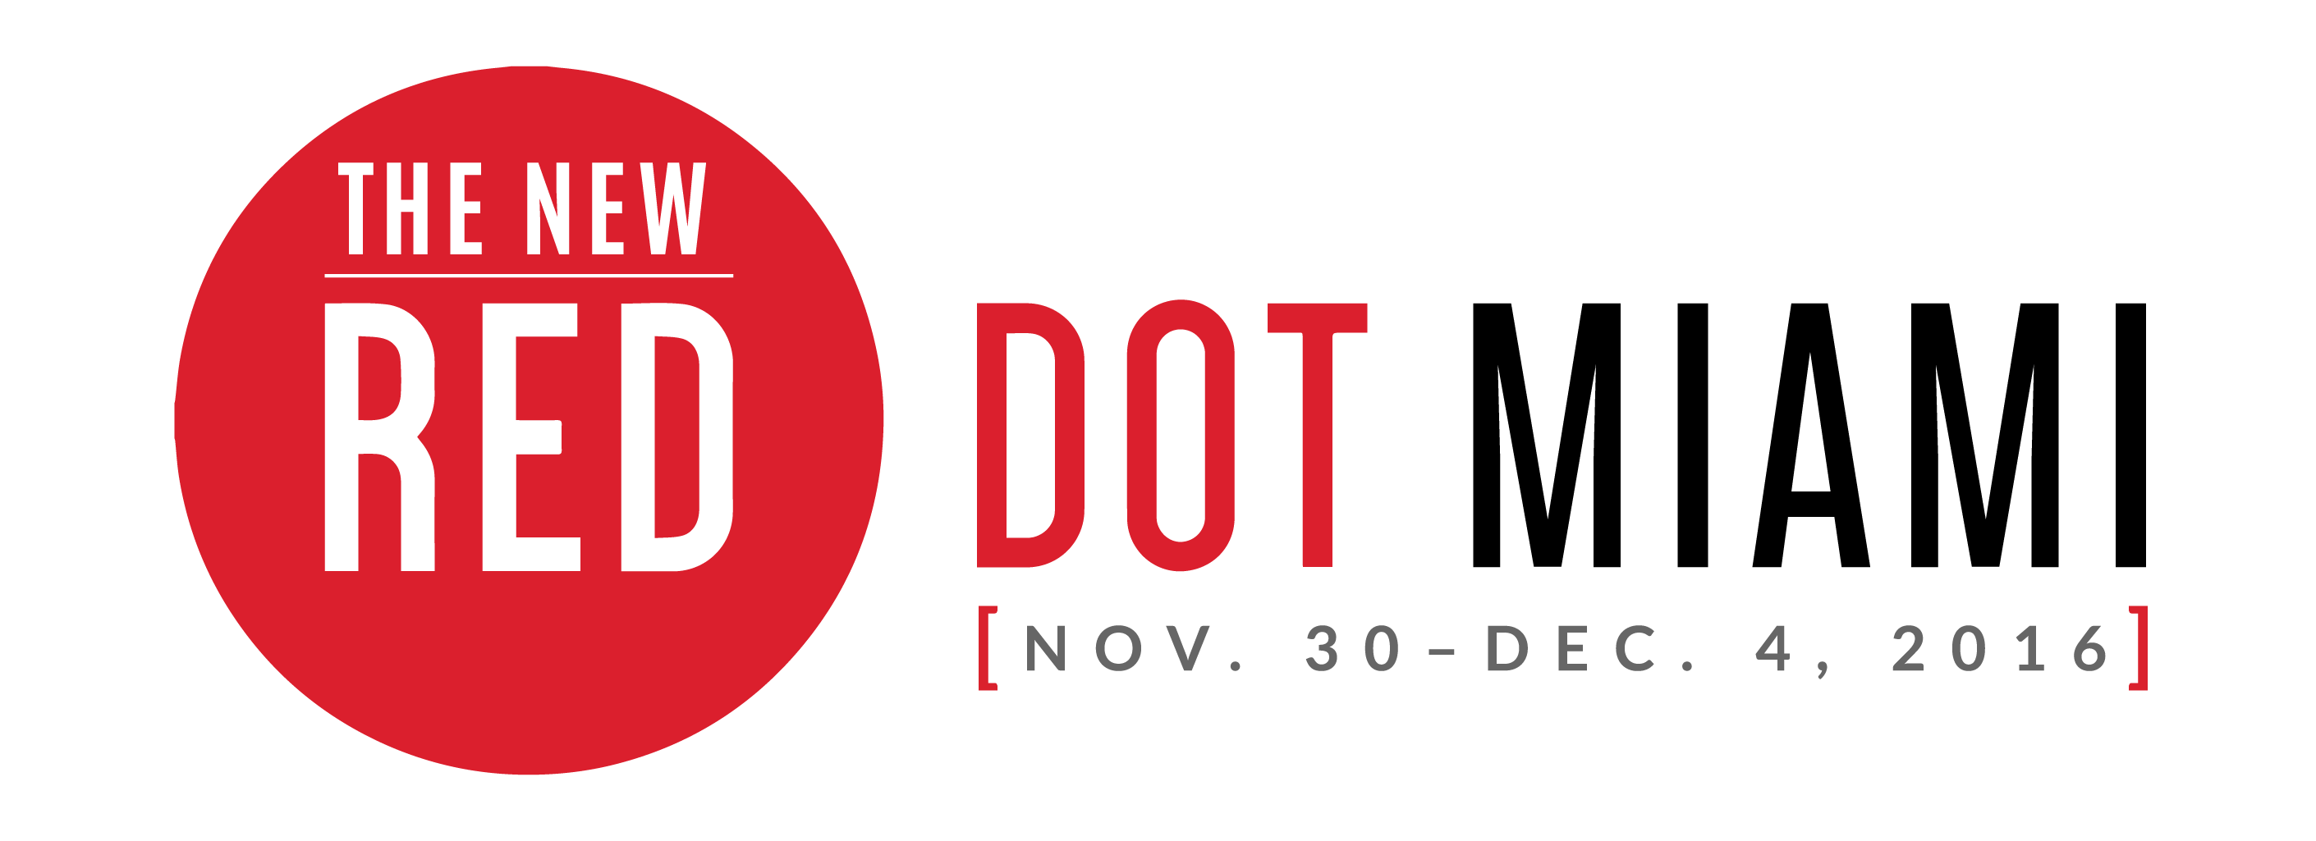

FOR IMMEDIATE RELEASE
Media Contact:
Jaclyn Walian
Olive PR Solutions, Inc.
m. 619-772-5602 o. 619-955-5285
jaclyn@oliveprsolutions.com

Deputy Minister of the Department of Small Business Development of South Africa Will Open Red Dot Miami
-Supporting the South African Art Collective, Ms. Elizabeth Thabethe will cut red ribbon
to open show-

MIAMI (Nov. XX, 2016) –Red Dot Miami is a juried contemporary art show taking place Nov. 30 – Dec. 4 in the heart of Miami’s Arts and Entertainment District. The Deputy Minister of the Department of Small Business Development of South Africa, Honorable Ms. Elizabeth Thabethe, will officially open Red Dot Miami with a ribbon cutting ceremony at 6 p.m. on Wednesday, November 30. The South African Department of Small Business Development will be supporting the South African Art Collective, a body of visual artwork on exhibit around the U.S, including a stop at Red Dot Miami.

“We are delighted to present the South African Art Collective at Art San Diego, Red Dot Miami and Artexpo New York. The participation in these platforms once more re-affirms our commitment as the South African government to support the creative industries through market access platforms that promise sustainable trade opportunities and returns on investment,” said Thabethe.

The South African Art Collective comprises art works produced by 20 artists from different parts of South Africa. The works are presented for sale to collectors, buyers and galleries and thus also aims to contribute to wider exposure and appreciation of South African art, culture and heritage whilst advancing trade objectives in relation to creative goods and services between the two Nations.

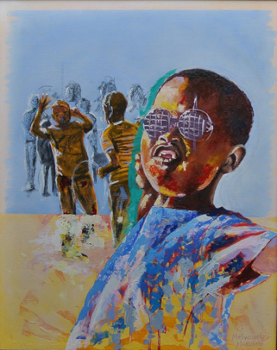
“Transition and Eruption” by Mziwoxolo Makalima

The creative industries played a significant role in the democratisation of South Africa and artists were central in the struggle against apartheid. “We strongly recognize the role that artists play in reflecting the various dynamics of our society and creating market access opportunities for our artists is a reaffirmation to our commitment to the development and advancement of the creative sector,” said Thabethe.

Red Dot Miami will feature up to 75 international galleries exhibiting paintings, sculpture, photography, and secondary market works. The theme this year is [EVOLVE]: At every turn, the art world is shifting. Galleries, artists, and collectors alike are continuously evolving, in turn imploring us to expand our perspectives.

“We are very honored that Ms. Thabethe will be in attendance and help us open the show,” said Eric Smith, president of Redwood Media Group, owner of Red Dot Miami. “The South African Art Collective is an exhibit not to be missed during Miami Art Week.”

“You are invited to share in the creative diversity and to support efforts in promoting South African artists, take with you an art piece from South Africa so that you can share in the beauty of her people,” said Thabethe.

Tickets for Red Dot Miami’s Opening Night Preview Party are priced at $50. General Admission tickets are $75 for all five days or $25 for one day. Tickets will also grant you access to Spectrum Miami. A percentage of all ticket sales benefit LIFE is ART, a local Miami-based charity. For more information on Red Dot Miami, please visit www.reddotmiami.com.

###

SHOW HOURS:
Opening Night Preview Party: Wednesday, November 30, 2016 | 6 – 10pm

General Public Show Hours:
Thursday, December 1, 2016 | 12 – 8pm
Friday, December 2, 2016 | 12 – 8pm
Saturday, December 3, 2016 | 12 – 8pm
Sunday, December 4, 2016 | 12 – 5pm

VENUE:
Red Dot Miami Tent
1700 NE 2nd Ave. at NE 17th St.
Miami, FL 33132

ADMISSION COST
Opening Night/5-Day Pass: $75 online / $85 at event
Opening Night Preview Pass: $50 online / $60 at event
General Admission, 1-Day Pass: $25 online / $30 at event
Seniors, 1-Day Pass: $15 online / $20 at event
Students, 1-Day Pass: $10 online / $20 at event

About Red Dot Miami:
Red Dot Miami, a juried, gallery-only contemporary art show in the heart of the Arts and Entertainment District, takes place annually in December (Nov. 30 – Dec. 4., 2016) as part of the popular Miami Art Week. Featuring up to 75 modern and contemporary galleries that represent more than 500 leading contemporary artists, Red Dot Miami has enriched the city’s arts scene beyond measure since its inception in 2006, becoming one of the leading satellite shows during Miami Art Week. For more information about Red Dot Miami, visit www.reddotmiami.com.

For further information please contact:
Mr Vuyisile Mshudulu
Department of Small Business Development
Tel: +27 (0) 12 394 5221
Cell: +27 (0) 78 016 3187
Email: vmshudulu@dsbd.gov.za
Web: www.dsbd.gov.za

