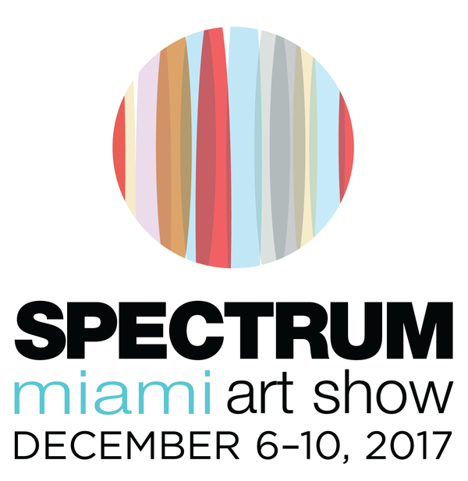
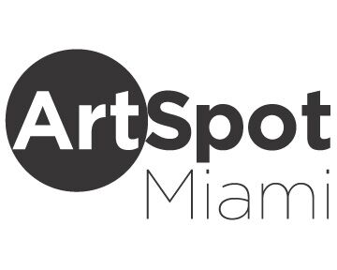
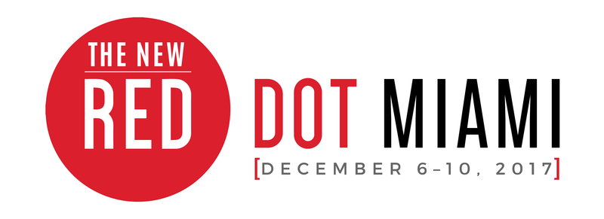
MEDIA CONTACT:
Elliott Stares
ESPR
305.490.1985
Elliott@esprinc.com
FOR IMMEDIATE RELEASE

SPECTRUM MIAMI AND RED DOT MIAMI FORM AN EXCLUSIVE CULTURAL PARTNERSHIP WITH THE PHILLIP AND PATRICIA FROST MUSEUM OF SCIENCE FOR MIAMI ART WEEK 2017

Science and Art collide with a unique ticketing program that allows curious minds to explore both the cosmos and contemporary exhibitions in
Miami’s Arts and Entertainment District

Miami, FL – November 14th, 2017: The stars have aligned between two of today’s most preeminent pioneers in the realms of science and the fine art industry, resulting in a unique cultural collaboration that will provide an exceptional level of access for contemporary trend hunters during this year’s Miami Art Week.

Redwood Media Group, the nation’s leader in exhibition production, media and marketing for the global fine art community, announces an exclusive Cultural Partnership between its premier South Florida shows – Spectrum Miami and Red Dot Miami — and one of the country’s leading science museums, the Phillip and Patricia Frost Museum of Science, based in Downtown Miami’s Museum Park. This strategic alliance marks the first affiliation by Frost Science with a major art show since opening in May this year, and will position Redwood Media Group as an official donor, contributing toward the museum’s mission to create lifelong science and technology learning. The unique partnership will enable those who purchase a Total Experience Ticket at Frost Science during Miami Art Week (Dec. 6—10) to gain free admission to Red Dot Miami, Spectrum Miami and its show within a show – ArtSpot Miami – a contemporary exhibition by international and Latin American artists, celebrating its fifth anniversary in December. Guests of Frost Science simply have to show their ticket at the entrance of Spectrum Miami and Red Dot Miami any time over the five-day period for free admission. Frost Science members will also receive free admission by showing their membership ID card.

Taking place December 6—10 during Miami Art Week, Spectrum Miami and Red Dot Miami are established as sister art shows, occupying a purpose-built exhibition space on NE 2nd Avenue in Miami’s Arts and Entertainment District for the past two years. Over the last decade, both shows have grown to become the ultimate destination for the fine art industry professional and contemporary art enthusiast who collectively seek a more accessible experience with exhibits showcasing the world’s most progressive portfolios by some of today’s elite artists, galleries and emerging talents. The shows attract more than 38,000 attendees each year and represent more than 650 artists and galleries worldwide.

“We are thrilled to announce our exclusive Cultural Partnership with the Phillip and Patricia Frost Museum of Science,” said Eric Smith, CEO of Redwood Media Group. “We value the realm of science as an art form and see its role within the scope of visual arts as increasingly significant and vital in today’s world. Our shows represent art as an evolving genre that often takes a scientific approach. We are delighted to offer free admission to the patrons and guests of Frost Science during Miami Art Week and look forward to developing more exciting initiatives with the region’s most coveted museum.”

Cont/d…

2/…

“We’re pleased to form this unique strategic alliance with two well-established art fairs during Miami Art Week,” said Frank Steslow, President of Frost Science. “Science and art are entwined within the same cultural thread and we look forward to providing our patrons and guests with access to these truly outstanding shows.”

Red Dot Miami, a curated gallery-only contemporary art show, now in its 11th year, presents [IMPACT] as the curatorial theme for 2017. Art not only reflects society but also influences it. From individual creative explorations to large-scale exhibitions seen by millions, the [IMPACT] art has on all is immeasurable. This theme forms a common thread throughout the special exhibits and programming that showcases exhibitors, art industry professionals, and select nonprofits and institutions. Red Dot Miami features galleries representing over 500 leading contemporary artists from primary and secondary markets throughout the world. The five-day show attracts more than 30,000 visitors and high-net-worth collectors who interact with the specially curated programming, which includes the Spotlight Gallery Program, a focused look at several cutting-edge galleries chosen by the Redwood Media Group selection committee; Art Labs, a series of outstanding projects by leading galleries, art institutions, and art collectives within the show; and Art Talks, an inside look at the artistic experience by way of panel discussions, conversations, and provocative artistic discourse with leading artists, curators, designers, and art industry professionals.

Spectrum Miami, a curated, contemporary art show, now in its seventh year, presents special programs and site-specific exhibitions that showcase the thriving art landscape of the city, informed by the 2017 curatorial theme [FUSION]: the merging of artistic mediums, of exhibitors and collectors, and of the countless galleries and artists who come together to showcase their work. Spectrum Miami is where contemporary meets extraordinary, featuring the works of more than 160 exhibiting artists and galleries from the Florida region and around the globe. Known for its urban and upscale works of art, Spectrum Miami includes Art Labs and Art Talks as well as the Spotlight Artists Program, providing collectors with a focused look at several prominent artists who will each be creating a site-specific exhibition, and the LaunchPad Artist Program, showcasing an emerging and unrepresented artist who is selected to create an exhibition at the show, resulting from a collaboration among local art institutions, galleries, and Spectrum Miami. Spectrum Miami will also include [FOTO SOLO], a stand-alone exhibit, introduced at Artexpo New York in 2016, that features up to 10 artists from various continents who have been chosen for their exemplary photographic art.

ArtSpot Miami will be celebrating its fifth anniversary within Spectrum Miami in 2017. ArtSpot Miami is a specially curated show by Aldo Castillo, an international art dealer and curator. A forward-thinking art show exhibiton specializing in modern and contemporary art with an emphasis on international and Latin American artists, ArtSpot offers innovative and alternative art to affluent collectors, worldwide art institutions, designers, architects, and art enthusiasts.

–Ends–

For further information, to arrange an interview, or to request media credentials, please contact:

Elliott Stares
ESPR
305.490.1985
Elliott@esprinc.com

GENERAL INFORMATION: SPECTRUM MIAMI – RED DOT MIAMI – ARTSPOT MIAMI

LOCATION (all three shows)
1700 NE 2nd Ave. (NE 17th Street)
Miami, FL 33132

ADMISSION COST (all three shows)
Opening Night Preview Pass: $50 online / $60 at event
Total Ticket: Opening Night + 5-Day Pass: $75 online / $85 at event
General Admission, 1-Day Pass: $25 online / $30 at event
Seniors, 1-Day Pass: $15 online / $20 at event
Students, 1-Day Pass: $10 online / $15 at event

OPENING NIGHT PREVIEW PARTY
Wednesday, December 6th: 6:00PM – 10:00PM

SHOW HOURS (all three shows)
Thursday, December 7th: 1:00PM – 9:00PM
Friday, December 8th: 1:00PM – 10:00PM
Saturday, December 9th: 1:00PM – 9:00PM
Sunday, December 10th: 12:00PM – 5:00PM

ONLINE
Spectrum Miami Website — www.spectrum-miami.com
Spectrum Miami on Facebook — www.facebook.com/SpectrumMiamiArtShow
Spectrum Miami on Twitter — www.twitter.com/SpectrumMiami
Spectrum Miami on Instagram — @spectrummiami
Red Dot Miami Website — www.reddotmiami.com
Red Dot Miami on Facebook — www.facebook.com/Red-Dot-Art-Fair
Red Dot Miami on Instagram — @reddotmiami
ArtSpot Miami Website — www.artspotmiami.com
ArtSpot Miami on Facebook — www.facebook.com/ArtSpotShow

About Spectrum Miami and Red Dot Miami
Now in its 7th year, Spectrum Miami, a curated contemporary art show in the heart of the Arts and Entertainment District, takes place annually in December as part of the popular Miami Art Week. Spectrum Miami is where contemporary meets extraordinary, featuring the works of more than 160 exhibiting artists and galleries from the Florida region and around the globe. Spectrum Miami celebrates the fine art experience with five days of music, entertainment, and other special events, and has emerged as one of the best-attended cultural events in Miami by highlighting thousands of innovative works among Miami’s top talent. ArtSpot Miami will be celebrating its fifth anniversary within Spectrum Miami in 2017. ArtSpot Miami is a specially curated show by Aldo Castillo, an international art dealer and curator, specializing in modern and contemporary art with an emphasis on international and Latin American artists. For more information about Spectrum Miami, visit spectrum-miami.com.

Now in its 12th year, Red Dot Miami, a curated gallery-only contemporary art show in the heart of the Arts and Entertainment District, takes place annually in December as part of the popular Miami Art Week. Red Dot Miami features up to 75 modern and contemporary galleries representing over 500 leading contemporary artists from primary and secondary markets throughout the world. The five-day show attracts more than 30,000 visitors and high-net-worth collectors who interact with the specially curated programming. Red Dot Miami has enriched the city’s arts scene beyond measure since its inception in 2006, becoming one of the leading satellite shows during Miami Art Week. For more information about Red Dot Miami, visit reddotmiami.com.

About the Phillip and Patricia Frost Museum of Science (Frost Science)
Located in Downtown Miami’s Museum Park, the Phillip and Patricia Frost Museum of Science is a leading science museum dedicated to sharing the power of science, sparking wonder and investigation, and fueling innovation for the future. Sitting on four acres, the 250,000-square-foot museum is divided into four buildings: the Frost Planetarium, Aquarium, and the North and West Wings. At Frost Science, visitors can explore the world of science, technology, engineering and math (STEM) in an experiential setting with interactive exhibitions and unique shows. Frost Science is supported by the Miami-Dade County Department of Cultural Affairs and the Cultural Affairs Council, the Miami-Dade County Mayor and Board of County Commissioners of Miami-Dade County. This project is supported by the Building Better Communities Bond Program and the City of Miami. It is sponsored, in part, by the State of Florida, Department of State, Division of Cultural Affairs and the Florida Council on Arts and Culture. The museum is accredited by the American Alliance of Museums, is an affiliate of the Smithsonian Institution and a member of the Association of Science and Technology Centers. Learn more at frostscience.org

About Redwood Media Group
Since 2009, Redwood Media Group (RMG) has been revolutionizing the global fine art community by helping artists and gallery owners grow their businesses through fine art exhibitions and publications, art business education, mentoring, marketing, and social media. Today, RMG owns and operates six fine art shows: Artexpo New York, Artexpo Las Vegas, Spectrum Miami, Art San Diego, Art Santa Fe, and Red Dot Miami. Artexpo New York, the world's largest fine art trade show for 40 years and counting, attracts more than 40,000 art enthusiasts every year, including nearly 5,000 industry buyers. Spectrum Miami and Red Dot Miami take place during Miami Art Week, an annual attraction that draws over 100,000 art collectors to the city. Over the past eight years, RMG has welcomed hundreds of thousands of visitors to their events, sold millions of dollars' worth of art, and helped thousands of unrepresented and established artists launch or grow their careers. Aside from hosting multiple high-end art shows
throughout the year, RMG also owns Art Business News.

For more information, visit www.redwoodmg.com, www.artbusinessnews.com, www.artexponewyork.com, www.artexpolasvegas.com, www.art-sandiego.com, www.spectrum-miami.com, www.artsantafe.com, and www.reddotmiami.com.

***

