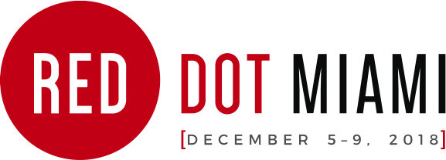
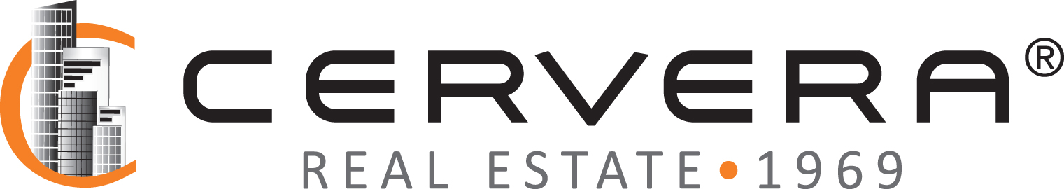
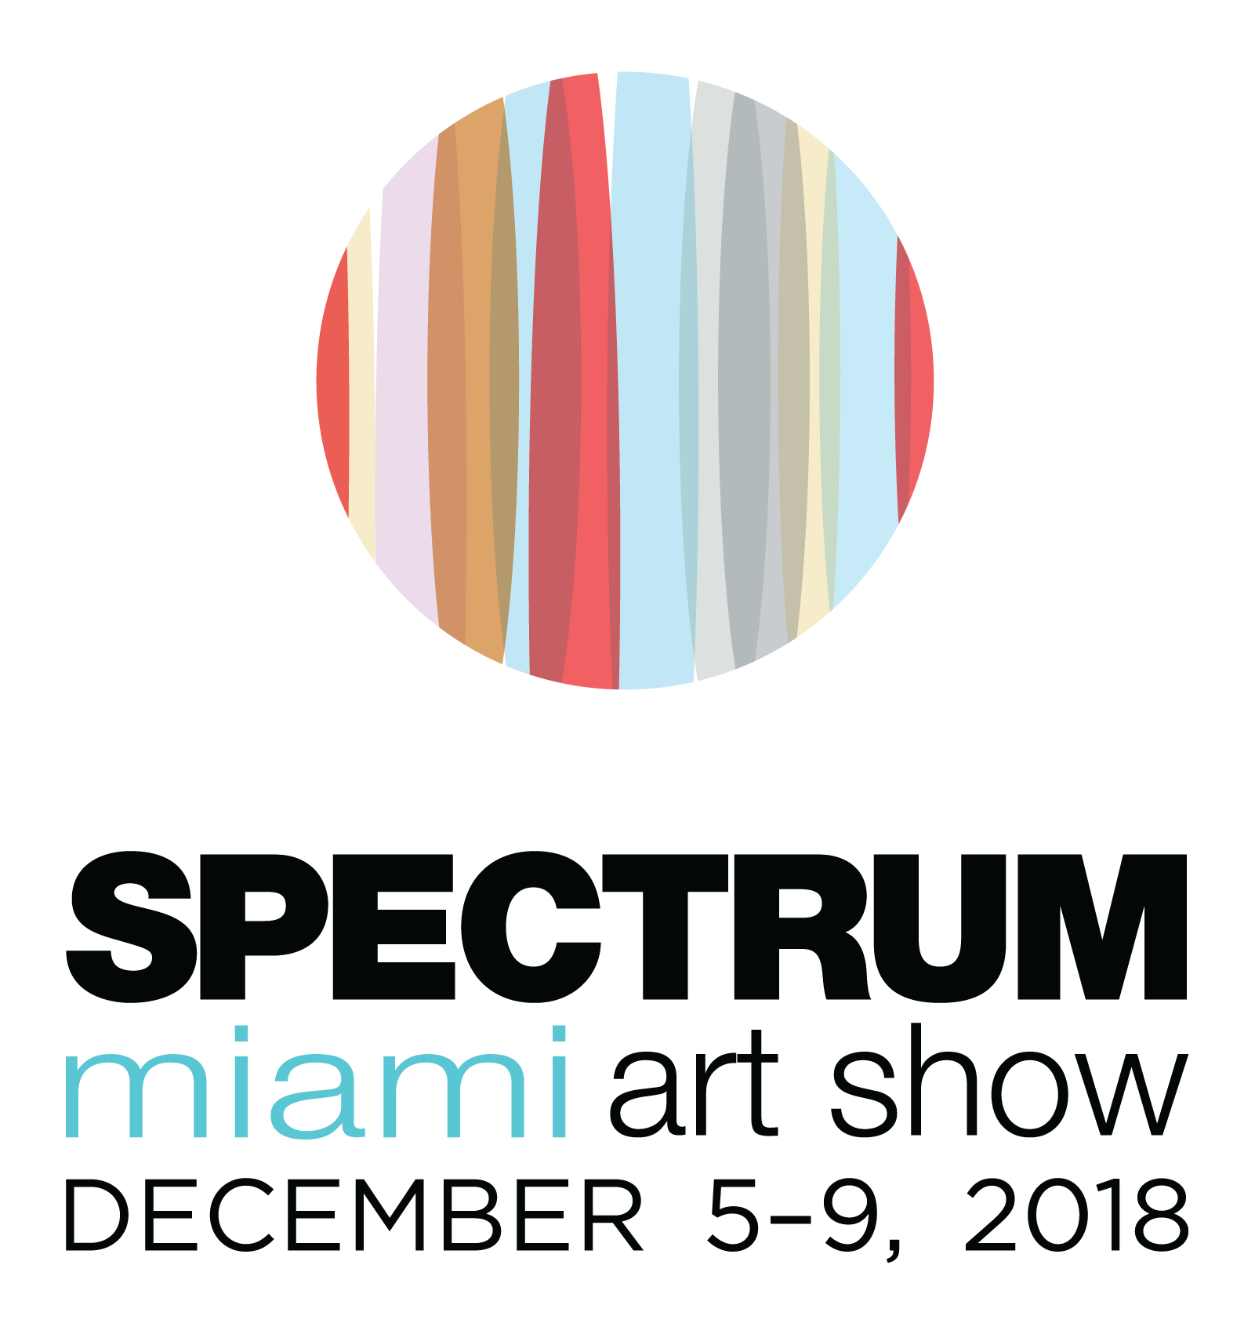

MEDIA CONTACT:
Elliott Stares
ESPR
305.490.1985
Elliott@esprinc.com

FOR IMMEDIATE RELEASE

CERVERA REAL ESTATE JOINS RED DOT MIAMI AND SPECTRUM MIAMI AS THE EXCLUSIVE LUXURY LIFESTYLE PARTNER FOR MIAMI ART WEEK 2018

Preeminent real estate pioneer presents The Art of Living as part of an engaging series of sponsorship programming at MANA Wynwood, Dec. 5—9

Miami, FL – December 3rd, 2018: Returning for a second year to form a strategic alliance with two of Miami Art Week’s longest running independent art shows, Cervera Real Estate joins Red Dot Miami and Spectrum Miami as the exclusive Luxury Lifestyle Partner during the biggest week on the art world’s calendar.

Redwood Media Group, the nation’s leader in exhibition production, media and marketing for the global fine art community, announces the ongoing partnership between its premier South Florida shows and one of the region’s leading real estate pioneers, as Red Dot Miami and Spectrum Miami commences with its five-day artistic showcase at its new home in MANA Wynwood, located at 2217 NW 5th Ave. in Miami, taking place December 5—9.

Cervera Real Estate, a Miami-based luxury real estate brokerage with a 50-year heritage defined by performance, innovation, and a passion for selling homes where beautiful memories are made, presents “The Art of Living” collection at Red Dot Miami 2018. Featuring the best of South Florida’s existing and new-construction real estate offerings, including: Aston Martin Residences Miami, Aria on the Bay, Elysee Miami, Smart Brickell, and The Ocean Resort Residences Conrad Fort Lauderdale Beach, the collection showcases a variety of residences – ideal for either primary use, as a second-home, or flexible-use – for the discerning lover of life, beauty, art and sunshine.

“We are very excited to continue our alliance with Cervera Real Estate as our exclusive Luxury Lifestyle Partner during this year’s Red Dot Miami and Spectrum Miami,” says Eric Smith, president of Redwood Media Group. “The Art of Living represents real estate excellence and the very best from the region’s luxury property market. Our shows attract a world-class caliber of art enthusiast and collector who also subscribe to a premium level of luxury living that these properties offer. The fine art world and luxury real estate market form the perfect marriage and there could not be a better synergy between Cervera’s unique collection and our affluent audience who attend the shows each year.”

The Art Of Living collection by Cervera Real Estate forms one of this year’s Art Labs inside Red Dot Miami, unveiled at the Opening Night Preview Party, taking place on Wednesday, December 5th, starting at 6:00 p.m. To commemorate the opening of the fairs, Cervera’s Managing Partner, Alicia Cervera Lamadrid, will join Redwood Media Group CEO, Eric Smith, and Michael Joseph, co-founder of Artblend, for the prestigious ribbon cutting ceremony that will mark the show’s 13th year in Miami. International art aficionados from across the globe will enjoy an evening of cocktails, Louis Jadot Wines, and a first look at this year’s exhibitors.

Cont/d…

2/…

On Thursday, December 6th, Cervera’s Vice President of Corporate Communications, Omar De Windt, will present "Miami Real Estate Podcast" on the topic of "Art & its Role in Miami's cultural proliferation” among other related segments. The live Podcast will feature a number of guests, including Redwood Media Group’s Managing Director of Marketing, Linda Mariano, together with Eric Smith, president of Redwood Media Group. The Podcast will be streamed on iTunes, Google Play, Spotify and Podbean apps, live on Cervera’s Facebook and Instagram channels, and on www.MiamiRealEstatePodcast.com. ART AFTER DARK, on Friday, December 7th, is sponsored in association with Cervera Real Estate, Planet Fashion TV and Louis Jadot Wines, offering extended late night opening hours for both shows, beginning at 6:00 p.m. until 10:00 p.m. – remaining open on Friday longer than any other show during Miami Art Week.

“We’re delighted to continue our strategic alliance with Red Dot Miami and Spectrum Miami,” says Veronica Cervera Goeseke, CEO of Cervera Real Estate. “The Art Of Living collection by Cervera will provide a unique appeal to attending art enthusiasts and collectors alike, while exemplifying the harmony that exists between art buying and luxury living. We look forward to an exciting lineup of programming at this year’s fairs.”

Red Dot Miami, a curated gallery-only contemporary art show, now in its 13th year, will be located inside Mana Wynwood. Red Dot Miami presents [ILLUMINATE] as the curatorial theme for 2018. From works that inspire awe and wonder to sweeping series that reveal new trends to artists who throw light on the roots of imagination through fearless creativity, Red Dot Miami illuminates the best the contemporary art world has to offer. This theme forms a common thread throughout the special exhibits and programming that showcases exhibitors, art industry professionals, and select nonprofits and institutions. Red Dot Miami features more than 60 galleries representing over 500 leading contemporary artists from primary and secondary markets throughout the world. The five-day show attracts more than 35,000 visitors and high-net-worth collectors who interact with the specially curated programming, which includes the Spotlight Program, a focused look at several cutting-edge galleries chosen by the Redwood Media Group selection committee. This years Spotlight Galleries include Aced Gallery (R615), Contemporary Art Projects USA (R103), DATG Concept (R215), Gebhardt Gallery & Studio (R312), and Zenith Art & Fashion (R406). This year’s Art Labs include The Art Of Living Collection by Cervera Real Estate, ART LOVES FASHION, a special presentation of cutting-edge music and fashion by Planet Fashion TV and MUSES AMUSE, curated by Contemporary Arts Projects USA, located at the Red Dot entrance lobby and throughout the show. Red Dot Miami will also feature Meet The Artists program, allowing collectors and attending art enthusiasts to interact with featured exhibitors and their live demonstrations.

Spectrum Miami, an upscale and urban curated contemporary art show, now in its 8th year, will be located adjacent to Red Dot Miami at Mana Wynwood. Spectrum Miami presents special programs and site-specific exhibitions that showcase the thriving art landscape of the city, informed by the 2018 curatorial theme [ALLURE]. Atmospheric abstracts. Provocative photographs. Seductive sculptures. The allure of contemporary and modern art is mysteriously and undeniably powerful. Spectrum Miami is where contemporary meets extraordinary, featuring the works of more than 160 exhibiting artists and galleries from the Florida region, the U.S. and around the globe. Known for its urban and upscale works of art, This year’s Art Labs includes Max Daily, one of the 2018 San Diego Art Prize's winning recipients, who brings his most recent creation, the Oslo Sardine Bar; and the debut of the Miami Selects Awards throughout the show. The Spectrum Miami Selects prestigious panel of judges will make their favorite artwork choices on Wednesday, December 5, at the Opening Night Preview Party. This year’s Spotlight Program is a specially curated group of program recipients, that includes Artblend (Booths 105 & 108), Doug Powell Art (Booth 331), Marianne Enhorning Design (Booth 502), Mecenavie Gallery (Booth 100) and The Tracy Piper (Booth 634). Meet The Artists program allows collectors and attending art enthusiasts to interact with featured exhibitors and watch their own live demonstrations.

Tickets for the Opening Night Preview Party are priced at $50 by purchasing online or $60 at the event. A General Admission 1-day Pass for Red Dot Miami and Spectrum Miami is $25 by purchasing online or $30 at the event. A 5-day Pass that includes the Opening Night Preview Party is $75 by purchasing online or $85 at the event.. Tickets grant access to both Red Dot Miami and Spectrum Miami. For further information on the shows or to purchase tickets, please visit spectrum-miami.com and reddotmiami.com. For more information on Redwood Media Group, visit redwoodmg.com.

–Ends–
For further information, to arrange an interview, or to request media credentials, please contact:

Elliott Stares
ESPR
305.490.1985
Elliott@esprinc.com

About Cervera Real Estate
Cervera Real Estate is a Miami-based, family-owned and operated, international real estate company with the most successful sellouts of pre-construction condominiums in South Florida. The firm has played a role in every Miami real estate cycle since Alicia Cervera Sr. – referred to as the “Queen of Miami Real Estate” – founded the company in 1969. Since then, the Cervera name has sold more than 110 luxury high-rise condos across the region, representing $16 billion of pre-construction inventory and helping revitalize areas including Brickell, Miami Beach’s South of Fifth neighborhood, downtown Miami and Edgewater. As the first agency to exclusively represent developers in the sales and marketing of their projects, Cervera created a specialized field within the brokerage industry. The company was the first to market extensively in several international markets, including Latin America, Europe and the Middle East. Today, under the leadership of Veronica Cervera Goeseke, CEO, and Alicia Cervera Lamadrid, Managing Partner, Cervera continues to broaden those relationships while expanding its global reach. For more information, visit www.Cervera.com

About Red Dot Miami and Spectrum Miami
Discover Red Dot Miami, a contemporary art show in the heart of Miami featuring an international slate of galleries. The show features galleries showcasing over 500 leading contemporary artists, and includes Art Labs, events, and informative Art Talks focused on collecting. Now in its 13th year, the five-day event attracts over 35,000 visitors, a majority of whom are high-net-worth collectors. Join us for an unforgettable five days of cutting-edge art, entertainment, and special events. Discover Spectrum Miami, a curated contemporary art show in the heart of Miami’s artsiest ’hood. Back in the Wynwood District for the first time since 2015, Spectrum Miami is taking over the iconic Mana Wynwood. Featuring an international slate of artists and galleries, it’s where contemporary meets extraordinary. Join us for a five-day fine art experience, featuring Art Labs, Art Talks, Meet the Artist sessions, music, entertainment, and other special events.

About Redwood Media Group
Since 2009, Redwood Media Group (RMG) has been revolutionizing the global fine art community by helping artists and gallery owners grow their businesses through fine art exhibitions and publications, art business education, mentoring, marketing, and social media. Today, RMG owns and operates five fine art shows: Artexpo New York, Spectrum Miami, Art San Diego, Art Santa Fe, and Red Dot Miami. Artexpo New York, the world's largest fine art trade show for 40 years and counting, attracts more than 40,000 art enthusiasts every year, including nearly 5,000 industry buyers. Red Dot Miami and Spectrum Miami take place during Miami Art Week, an annual attraction that draws over 100,000 art collectors to the city. Over the past nine years, RMG has welcomed hundreds of thousands of visitors to their events, sold millions of dollars' worth of art, and helped thousands of unrepresented and established artists launch or grow their careers. Aside from hosting multiple high-end art shows throughout the year, RMG also owns Art Business News.

For more information, visit www.redwoodmg.com, www.artbusinessnews.com, www.artexponewyork.com, www.art-sandiego.com, www.spectrum-miami.com, www.artsantafe.com, and www.reddotmiami.com.

***

