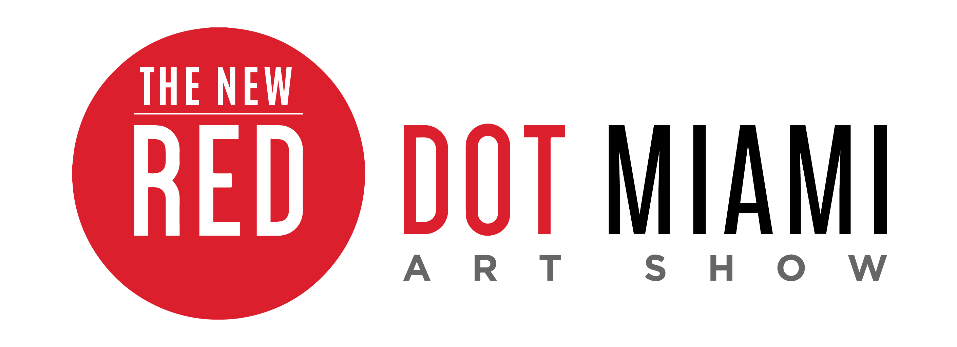
FOR IMMEDIATE RELEASE
Media Contact:
Jaclyn Walian
Olive PR Solutions, Inc.
m. 619-772-5602 o. 619-955-5285
jaclyn@oliveprsolutions.com

Red Dot Miami Boasts Robust Sales, Record Attendance, and Show Highlights from Miami Art Week
-Five-day fine art experience drew thousands of attendees and produced notable sales-

MIAMI (January X, 2017) – Red Dot Miami, a juried contemporary art show that takes place in the heart of the Arts and Entertainment District, today announced record attendance and robust sales. The all-new Red Dot Miami was celebrating its 10th year as a satellite show at Miami Art Week (November 30 through December 4, 2016) but was its premiere year under Redwood Media Group, owner and operator of Spectrum Miami. The five-day contemporary art show welcomed more than 38,000 attendees, including more than 9,000 during the Opening Night Preview Party. Red Dot Miami featured over 75 international galleries exhibiting paintings, sculpture, photography, and secondary market works. Red Dot Miami 2016 had notable sales of major works, with several galleries still finalizing pending sales and commissions.

“We are thrilled with the success of our first year operating Red Dot Miami,” said Eric Smith, president of Redwood Media Group. “We were able to bring an upgraded look and feel with wider aisles, deeper booths, new flooring, gallery styling, an exclusive VIP lounge, and new show programming—we can’t wait to see what next year brings.”

Every December, thousands of art collectors, gallery owners, dealers, curators, artists, and art lovers flock to Miami Art Week. Alongside the powerhouse shows of Art Basel, Art Miami, Scope, and Miami Project, Red Dot Miami provides an unforgettable five days of cutting-edge art, entertainment, and special events. Since its inception in 2006, Red Dot Miami has enriched the city’s arts scene beyond measure. Red Dot Miami continues to showcase galleries representing primary and secondary market artists, showing art to inspire attendees from all over the world with its site-specific Art Lab projects, Art Talks, specially selected Spotlight Galleries, special events, and more.

Additional 2016 show highlights included:
- The theme was [EVOLVE]: At every turn, the art world is shifting. Galleries, artists, and collectors alike are continuously evolving, in turn imploring us to expand our perspectives
- The Deputy Minister of the Department of Small Business Development of South Africa, Honorable Ms. Elizabeth Thabethe, officially opened Red Dot Miami with a ribbon-cutting ceremony
- Spotlight Galleries included Masterworks Fine Art, island6, and the Gallery Steiner
- Art Talk by Robin Hodes, editor of Florida Design Magazine, about designing a home for art collectors
- Art Labs included:
  - South African Art Collective: Sponsored by the South African Department of Small Business Development, the South African Art Collective showcased creative diversity, while supporting the goals of development and access in an expanded marketplace for the artists. It comprised artworks produced by 20 artists from different parts of South Africa
  - pARTicipate with Life is Art: Art met technology in an immersive art experience melding virtual reality, visual art, music, film, and fashion. A unique and exciting experience allowing visitors to interact and become part of the art as well as create their own works of art through virtual reality technology.
  - Light the Night: Searching for Perfection: dynamic light sculpture designed by Adrian Sierra Garcia
- Award winners included:
  - Best Booth Design: The Lawley Art Group
  - Directors’ Award: Masterworks Fine Art and Westbrook Modern Gallery
  - Best Sculpture Award: Ira Reines Sculpture at Winn Slavin Fine Art
  - Best International Exhibitor: South African Art Collective and Renssen Art Gallery

Notable Exhibitor Sales:
Galleries from around the world made great sales at the show, fostered connections with potential buyers, and garnered commissions for the year ahead. Here are some of the top sales and commissions from this year’s show:
- Lawley Art Group sold Lea Fisher’s “Dragon’s Dream” for $14,500 and JD Miller’s “Dragon’s Daydream” for $19,500
- Masterworks Fine Art sold Frank Stella’s “Shards,” an offset lithograph and screenprint, for $17,000
- Novem Fine Art sold Carla Wright’s “Daisies” oil on canvas for $19,500
- Renssen Art Gallery sold 12 works, including two Picassos and 10 pieces by Erik Renssen
- Conde Contemporary sold Darian Rodriguez’s “Auto Retrato” oil on canvas for $15,000
- Charles Harold Gallery sold 10 pieces
- James Baird Gallery sold a Yury Darashkevich artwork for $6,000
- Stamp Art Society of BC sold two Jennifer Harwood paintings for $1,200 and $2,700 and a Paul Burgoyne piece for $5,500
- Evan Lurie Gallery saw several sales, including “Lulamati” from Francisco Valverde for $8,000, and three mixed-media works from Ashleigh Sumner: “Jimi” for $8,500, “Native” for $5,500, and “Menage a Trois” for $6,500
- Bruce Lurie sold three pieces, the highest being “2 a.m.” for $4,000
- Vehement Art sold more than $8,500, including two of his mixed-media skulls
- South African Art Collective sold five pieces, ranging from $200 to $2,900
- Gallery of Music & Art sold “Marilyn in Mesh” for $2,500
- Winn Slavin Fine Art sold several pieces, including “Gates of Creation” by Ira Reines, “Ubiquitous” and “Innocence” by Daniel Winn, and a collection of six mixed-media works by Cory Bennett
- Other exhibiting galleries who made sales: Fine Art Maya, Michèle Fontanière Pop-up Gallery, Island6, David Bardia Art Gallery, Artblend, and Gallery Edel

Red Dot Miami is owned and operated by Redwood Media Group, organizer of leading art shows across the country, connecting top artists, gallery owners, and publishers with buyers, collectors, and dealers who love their work. Click here to view photos from Red Dot Miami 2016, and check out video highlights here. This year’s show, the 11th annual Red Dot Miami, will take place December 6–10, 2017. For more information about Red Dot Miami visit www.reddotmiami.com.

###
About Red Dot Miami:
Red Dot Miami, a juried, gallery-only contemporary art show in the heart of the Arts and Entertainment District, takes place annually in December as part of the popular Miami Art Week. Featuring up to 75 modern and contemporary galleries that represent more than 500 leading contemporary artists, Red Dot Miami has enriched the city’s arts scene beyond measure since its inception in 2006, becoming one of the leading satellite shows during Miami Art Week. For more information about Red Dot Miami, visit www.reddotmiami.com.

About Redwood Media Group:
Since 2009, Redwood Media Group (RMG) has been revolutionizing the global fine art community by helping artists and gallery owners grow their businesses through fine art exhibitions and publications, art business education, mentoring, marketing, and social media. Today, RMG owns and operates six fine art shows: Artexpo New York, Art San Diego, Spectrum Indian Wells, Spectrum Miami, Art Santa Fe, and Red Dot Miami. Artexpo New York, the world's largest fine art trade show for 38 years and counting, attracts more than 30,000 art enthusiasts every year, including 4,500 industry buyers. Spectrum Miami and RMG’s newest acquisition, Red Dot Miami, take place during Miami Art Week, an annual attraction that draws over 80,000 art collectors to the city. Over the past seven years, RMG has welcomed hundreds of thousands of visitors to their events, sold millions of dollars' worth of art, and helped thousands of unrepresented and established artists launch or grow their careers. Aside from hosting multiple high-end art shows throughout the year, RMG also owns Art Business News and DECOR magazines.

For more information, visit: www.redwoodmg.com, www.artbusinessnews.com, www.artexponewyork.com, www.art-sandiego.com, www.spectrum-miami.com, www.spectrum-indianwells.com, www.artsantafe.com, and www.reddotmiami.com.

