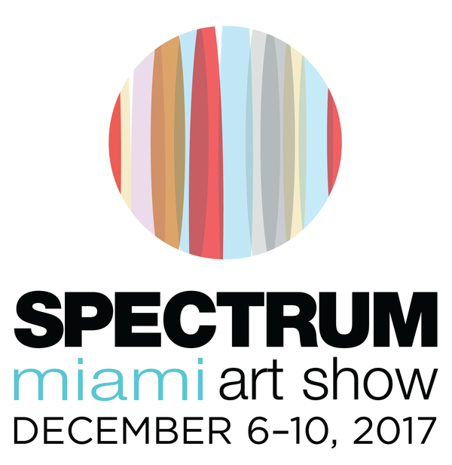
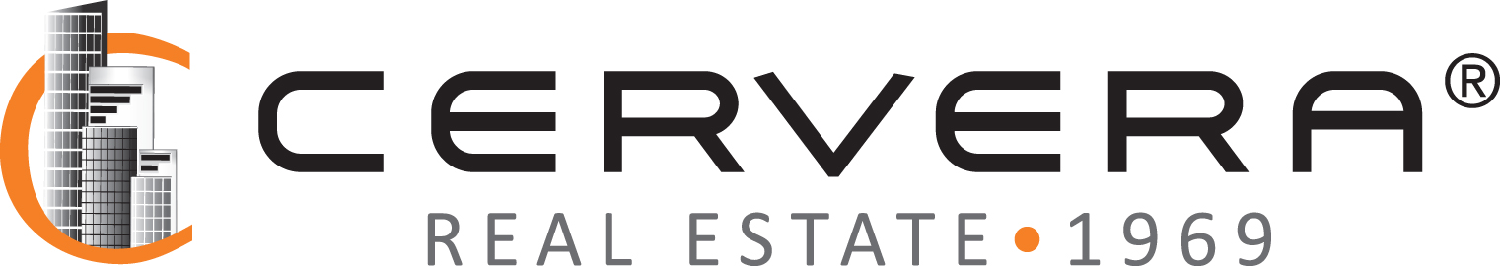
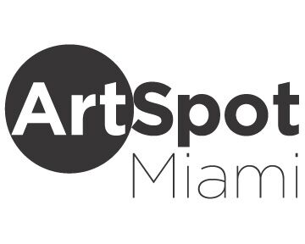
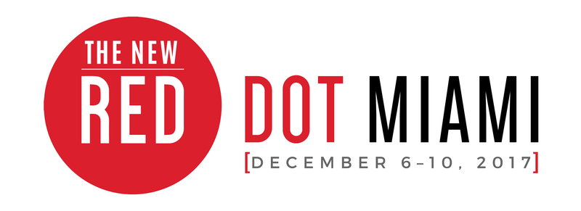
MEDIA CONTACT:
Elliott Stares
ESPR
305.490.1985
Elliott@esprinc.com
FOR IMMEDIATE RELEASE

SPECTRUM MIAMI AND RED DOT MIAMI FORM AN EXCLUSIVE LUXURY LIFESTYLE PARTNERSHIP WITH CERVERA REAL ESTATE FOR MIAMI ART WEEK 2017

Premier leader in South Florida’s real estate market to host the eleventh annual Opening Night Preview Party and Official Ribbon Cutting Ceremony

Miami, FL – November 30th, 2017: Adding to the eclectic group of cultural and lifestyle partners that now form a formidable coalition with two of Miami Art Week’s longest running fairs, is one of South Florida’s leading real estate pioneers, representing excellence in the luxury arena and a complementary strategic alliance during the biggest week on the art world’s calendar.

Redwood Media Group, the nation’s leader in exhibition production, media and marketing for the global fine art community, announces an exclusive Luxury Lifestyle Partnership between its premier South Florida shows – Spectrum Miami and Red Dot Miami, and one of the region’s leading real estate organizations, CERVERA Real Estate. This strategic alliance marks the first affiliation by Cervera with a major art show during Miami Art Week, resulting in unlimited access for the company’s high net worth clientele and property owners who view today’s contemporary art market as an attractive investment. Cervera Real Estate will be the exclusive sponsor of the Opening Night Preview Party for Spectrum Miami and Red Dot Miami, taking place on Wednesday, December 6th, starting at 6:00 p.m. To commemorate the opening of the fairs, Cervera’s CEO, Veronica Cervera Goeseke, and Managing Partner, Alicia Cervera Lamadrid, will join Redwood Media Group CEO, Eric Smith, for the prestigious ribbon cutting ceremony that will mark the show’s 11th year in Miami. Guests of Cervera will join international art aficionados from across the globe for an evening of cocktails and a first look at this year’s exhibitors.

Taking place December 6—10 during Miami Art Week, Spectrum Miami and Red Dot Miami are established as sister art shows, occupying a purpose-built exhibition space on NE 2nd Avenue in Miami’s Arts and Entertainment District for the past two years. Over the last decade, both shows have grown to become the ultimate destination for the fine art industry professional and contemporary art enthusiast who collectively seek a more accessible experience with exhibits showcasing the world’s most progressive portfolios by some of today’s elite artists, galleries and emerging talents. The shows attract more than 38,000 attendees each year and represent more than 650 artists and galleries worldwide.

“We are thrilled to announce our exclusive lifestyle partnership with one of the region’s most preeminent real estate leaders,” said Eric Smith, CEO of Redwood Media Group. “The clientele that Cervera Real Estate has been serving for over 48 years is extremely compatible with the audience of collectors and art enthusiasts that our shows attract in Miami and nationwide. These individuals often acquire second or third homes and are looking to fill the walls of a newly bought property or as part of a renovation project. These “nesters” live in a world where they’re aware of art and they want to own a meaningful collection, such as a print or work by an emerging artist. Art buyers today are increasingly purchasing work for their high-end homes, and South Florida is the epicenter for both luxury real estate and luxury art.”

Cont/d…

2/…

“We’re pleased to form this unique strategic alliance with two of the longest running art fairs during Miami Art Week,” said Veronica Cervera Goeseke, CEO of Cervera Real Estate. “Today’s contemporary art world is perfectly aligned with the current luxury real estate landscape, and this valuable partnership allows Cervera to offer its clientele an insider’s perspective on the existing trends within the fine art marketplace.”

Red Dot Miami, a curated gallery-only contemporary art show, now in its 11th year, presents [IMPACT] as the curatorial theme for 2017. Art not only reflects society but also influences it. From individual creative explorations to large-scale exhibitions seen by millions, the [IMPACT] art has on all is immeasurable. This theme forms a common thread throughout the special exhibits and programming that showcases exhibitors, art industry professionals, and select nonprofits and institutions. Red Dot Miami features galleries representing over 500 leading contemporary artists from primary and secondary markets throughout the world. The five-day show attracts more than 30,000 visitors and high-net-worth collectors who interact with the specially curated programming, which includes the Spotlight Gallery Program, a focused look at several cutting-edge galleries chosen by the Redwood Media Group selection committee; Art Labs, a series of outstanding projects by leading galleries, art institutions, and art collectives within the show; and Art Talks, an inside look at the artistic experience by way of panel discussions, conversations, and provocative artistic discourse with leading artists, curators, designers, and art industry professionals.

Spectrum Miami, a curated, contemporary art show, now in its seventh year, presents special programs and site-specific exhibitions that showcase the thriving art landscape of the city, informed by the 2017 curatorial theme [FUSION]: the merging of artistic mediums, of exhibitors and collectors, and of the countless galleries and artists who come together to showcase their work. Spectrum Miami is where contemporary meets extraordinary, featuring the works of more than 160 exhibiting artists and galleries from the Florida region and around the globe. Known for its urban and upscale works of art, Spectrum Miami includes Art Labs and Art Talks as well as the Spotlight Artists Program, providing collectors with a focused look at several prominent artists who will each be creating a site-specific exhibition, and the LaunchPad Artist Program, showcasing an emerging and unrepresented artist who is selected to create an exhibition at the show, resulting from a collaboration among local art institutions, galleries, and Spectrum Miami. Spectrum Miami will also include [FOTO SOLO], a stand-alone exhibit, introduced at Artexpo New York in 2016, that features up to 10 artists from various continents who have been chosen for their exemplary photographic art.

ArtSpot Miami will be celebrating its fifth anniversary within Spectrum Miami in 2017. ArtSpot Miami is a specially curated show by Aldo Castillo, an international art dealer and curator. A forward-thinking art show exhibiton specializing in modern and contemporary art with an emphasis on international and Latin American artists, ArtSpot offers innovative and alternative art to affluent collectors, worldwide art institutions, designers, architects, and art enthusiasts.

General Admission tickets for Spectrum Miami and Red Dot Miami are $25 for one day and $75 for the Opening Night Preview Party with a five-day pass. Tickets grant access to Spectrum Miami, Red Dot Miami and ArtSpot Miami. For further information on the shows or to purchase tickets, please visit spectrum-miami.com, reddotmiami.com, or artspotmiami.com.

–Ends–

For further information, to arrange an interview, or to request media credentials, please contact:

Elliott Stares
ESPR
305.490.1985
Elliott@esprinc.com

GENERAL INFORMATION:

LOCATION (all three shows)
1700 NE 2nd Ave. (NE 17th Street)
Miami, FL 33132

ADMISSION COST (all three shows)
Opening Night Preview Pass: $50 online / $60 at event
Total Ticket: Opening Night + 5-Day Pass: $75 online / $85 at event
General Admission, 1-Day Pass: $25 online / $30 at event
Seniors, 1-Day Pass: $15 online / $20 at event
Students, 1-Day Pass: $10 online / $15 at event

OPENING NIGHT PREVIEW PARTY
Wednesday, December 6th: 6:00PM – 10:00PM

SHOW HOURS (all three shows)
Thursday, December 7th: 1:00PM – 9:00PM
Friday, December 8th: 1:00PM – 10:00PM
Saturday, December 9th: 1:00PM – 9:00PM
Sunday, December 10th: 12:00PM – 5:00PM

ONLINE
Spectrum Miami Website — www.spectrum-miami.com
Spectrum Miami on Facebook — www.facebook.com/SpectrumMiamiArtShow
Spectrum Miami on Twitter — www.twitter.com/SpectrumMiami
Spectrum Miami on Instagram — @spectrummiami
Red Dot Miami Website — www.reddotmiami.com
Red Dot Miami on Facebook — www.facebook.com/Red-Dot-Art-Fair
Red Dot Miami on Instagram — @reddotmiami
ArtSpot Miami Website — www.artspotmiami.com
ArtSpot Miami on Facebook — www.facebook.com/ArtSpotShow

About Spectrum Miami and Red Dot Miami
Now in its 7th year, Spectrum Miami, a curated contemporary art show in the heart of the Arts and Entertainment District, takes place annually in December as part of the popular Miami Art Week. Spectrum Miami is where contemporary meets extraordinary, featuring the works of more than 160 exhibiting artists and galleries from the Florida region and around the globe. Spectrum Miami celebrates the fine art experience with five days of music, entertainment, and other special events, and has emerged as one of the best-attended cultural events in Miami by highlighting thousands of innovative works among Miami’s top talent. ArtSpot Miami will be celebrating its fifth anniversary within Spectrum Miami in 2017. ArtSpot Miami is a specially curated show by Aldo Castillo, an international art dealer and curator, specializing in modern and contemporary art with an emphasis on international and Latin American artists. For more information about Spectrum Miami, visit spectrum-miami.com.

Now in its 11th year, Red Dot Miami, a curated gallery-only contemporary art show in the heart of the Arts and Entertainment District, takes place annually in December as part of the popular Miami Art Week. Red Dot Miami features up to 75 modern and contemporary galleries representing over 500 leading contemporary artists from primary and secondary markets throughout the world. The five-day show attracts more than 30,000 visitors and high-net-worth collectors who interact with the specially curated programming. Red Dot Miami has enriched the city’s arts scene beyond measure since its inception in 2006, becoming one of the leading satellite shows during Miami Art Week. For more information about Red Dot Miami, visit reddotmiami.com.

About Cervera Real Estate
Cervera Real Estate is a Miami-based, family-owned and operated, international real estate company with the most successful sellouts of pre-construction condominiums in South Florida. The firm has played a role in every Miami real estate cycle since Alicia Cervera Sr. – referred to as the “Queen of Miami Real Estate” – founded the company in 1969. Since then, the Cervera name has sold more than 110 luxury high-rise condos across the region, representing $16 billion of pre-construction inventory and helping revitalize areas including Brickell, Miami Beach’s South of Fifth neighborhood, downtown Miami and Edgewater. As the first agency to exclusively represent developers in the sales and marketing of their projects, Cervera created a specialized field within the brokerage industry. The company was the first to market extensively in several international markets, including Latin America, Europe and the Middle East. Today, under the leadership of Veronica Cervera Goeseke, CEO, and Alicia Cervera Lamadrid, Managing Partner, Cervera continues to broaden those relationships while expanding its global reach. For more information, visit www.Cervera.com

About Redwood Media Group
Since 2009, Redwood Media Group (RMG) has been revolutionizing the global fine art community by helping artists and gallery owners grow their businesses through fine art exhibitions and publications, art business education, mentoring, marketing, and social media. Today, RMG owns and operates six fine art shows: Artexpo New York, Artexpo Las Vegas, Spectrum Miami, Art San Diego, Art Santa Fe, and Red Dot Miami. Artexpo New York, the world's largest fine art trade show for 40 years and counting, attracts more than 40,000 art enthusiasts every year, including nearly 5,000 industry buyers. Spectrum Miami and Red Dot Miami take place during Miami Art Week, an annual attraction that draws over 100,000 art collectors to the city. Over the past eight years, RMG has welcomed hundreds of thousands of visitors to their events, sold millions of dollars' worth of art, and helped thousands of unrepresented and established artists launch or grow their careers. Aside from hosting multiple high-end art shows
throughout the year, RMG also owns Art Business News.

For more information, visit www.redwoodmg.com, www.artbusinessnews.com, www.artexponewyork.com, www.artexpolasvegas.com, www.art-sandiego.com, www.spectrum-miami.com, www.artsantafe.com, and www.reddotmiami.com.

***

