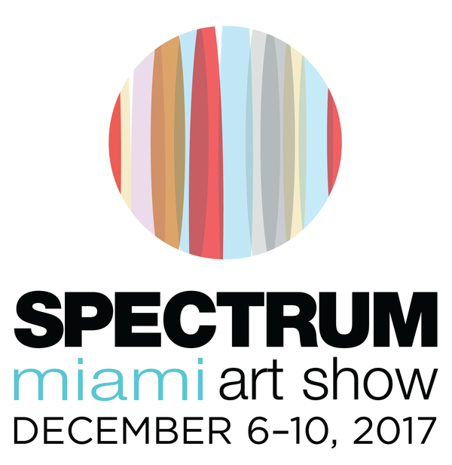
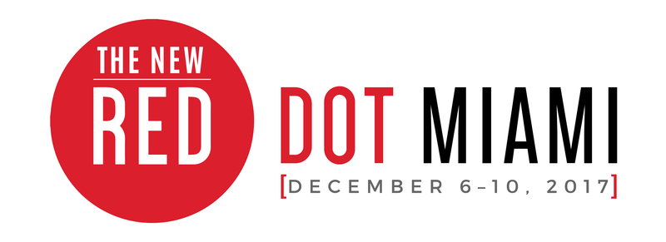
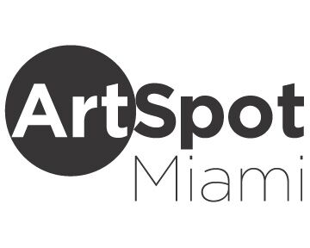
MEDIA CONTACT:
Elliott Stares
ESPR
305.490.1985
Elliott@esprinc.com
FOR IMMEDIATE RELEASE

RED DOT MIAMI ARTIST TO EXHIBIT SIGNATURE ART ON CONCRETE SALVAGED FROM THE EARTHQUAKE IN MEXICO

Contemporary Art Projects USA presents a unique gallery collection by acclaimed structural artist from Mexico, Ricardo Cárdenas

Miami, FL – November 29th, 2017: A successful construction engineer and artist from Mexico is showcasing his signature collection of paintings and sculptures during Miami Art Week, that cleverly uses building materials, such as concrete and steel bars, as his artistic media. The centerpiece for his exhibit – an abstract Warhol-like depiction of Tic Tac Toe and Frida Kahlo painted on concrete salvaged from the recent earthquake in Mexico – priced at $10,000.

Miami based gallerist and founder of Contemporary Art Projects USA, Tata Fernandez, saw the emerging potential of the inspired collection developed by the Mexican engineer, Ricardo Cárdenas, and started representing Cárdenas, the artist, in the U.S starting in 2015. A number of his concrete works of art will form part of the Contemporary Art Projects gallery exhibition at this year’s Red Dot Miami, curated by Mariavelia Savino, taking place December 6—10. The focal point of Cárdenas’ presentation will be a 72 x 72 inch piece of concrete that was recovered from the Mexican earthquake in September and used as a canvas to transform the rubble in to a work of art Cárdenas entitled “El Juego de las Fridas.” For this extraordinary artwork, he merges a double tribute between two Great Masters: Frida Kahlo (b. 1907-d. 1954, Mexico) and Andy Warhol (b. 1928-d. 1987, USA). Using mixed media, including acrylic and oil as a collage technique to portray the popular Tic Tac Toe game, this allows him to depict several images of Frida displayed in the characteristic multicolored Warhol manner. His tributes and the fusion that Cardenas creates between the diverse artistic visions are made to celebrate Frida Khalo and Andy Warhol, progressing from his original tributes to renowned masters such as Pablo Picasso, Michelangelo and Leonardo Da Vinci in previous works. His prized possession will be transported from Mexico as part of the Contemporary Art Projects gallery exhibit at Red Dot Miami in the Arts and Entertainment District opening on Wednesday. Ricardo Cárdenas’ complete anthology can be found by visiting www.ricardocardenaseddy.com

"My autobiographical work ‘Paramo’ reunites elements from my structural engineer profession merged with creative concepts inspired by the artistic movement "Arte Povera," says Cárdenas. “I narrate events of my life, expressing feelings and beliefs using building materials, concrete and steel. Paramo describes an arid desert at a certain altitude: somber, ignored, plagued by fog, rain, clouds, rocks and wind, where loneliness becomes evident. It reunites life’s energies where men connect with their gods and incomprehensible forces that can't be dominated."

“Ricardo Cárdenas is a genuine and original creator, always presenting new and unique proposals,” says Tata Fernandez of Contemporary Art Projects USA. “I admired his exquisite Series of Tributes to Great Masters – reinterpreting the main traits of the art from a chosen master artist, using cement and iron bars as his canvas for the characteristic of his work. Ricardo paints as a collage, making his pieces seem like a poster or street graffiti on a cement wall. The resulting artwork is just astonishing and has been greatly admired by different audiences and art collectors. We can certainly say that these works are like contemporary walls that he brings from Mexico to delight and inspire art lovers everywhere.”

2/…

Red Dot Miami, a curated gallery-only contemporary art show, now in its 11th year, presents [IMPACT] as the curatorial theme for 2017. Art not only reflects society but also influences it. From individual creative explorations to large-scale exhibitions seen by millions, the [IMPACT] art has on all is immeasurable. This theme forms a common thread throughout the special exhibits and programming that showcases exhibitors, art industry professionals, and select nonprofits and institutions. Red Dot Miami features galleries representing over 500 leading contemporary artists from primary and secondary markets throughout the world. The five-day show attracts more than 30,000 visitors and high-net-worth collectors who interact with the specially curated programming, which includes the Spotlight Gallery Program, a focused look at several cutting-edge galleries chosen by the Redwood Media Group selection committee; Art Labs, a series of outstanding projects by leading galleries, art institutions, and art collectives within the show; and Art Talks, an inside look at the artistic experience by way of panel discussions, conversations, and provocative artistic discourse with leading artists, curators, designers, and art industry professionals.

Spectrum Miami, a curated, contemporary art show, now in its seventh year, presents special programs and site-specific exhibitions that showcase the thriving art landscape of the city, informed by the 2017 curatorial theme [FUSION]: the merging of artistic mediums, of exhibitors and collectors, and of the countless galleries and artists who come together to showcase their work. Spectrum Miami is where contemporary meets extraordinary, featuring the works of more than 160 exhibiting artists and galleries from the Florida region and around the globe. Known for its urban and upscale works of art, Spectrum Miami includes Art Labs and Art Talks as well as the Spotlight Artists Program, providing collectors with a focused look at several prominent artists who will each be creating a site-specific exhibition, and the LaunchPad Artist Program, showcasing an emerging and unrepresented artist who is selected to create an exhibition at the show, resulting from a collaboration among local art institutions, galleries, and Spectrum Miami. Spectrum Miami will also include [FOTO SOLO], a stand-alone exhibit, introduced at Artexpo New York in 2016, that features up to 10 artists from various continents who have been chosen for their exemplary photographic art.

ArtSpot Miami will be celebrating its fifth anniversary within Spectrum Miami in 2017. ArtSpot Miami is a specially curated show by Aldo Castillo, an international art dealer and curator. A forward-thinking art show exhibiton specializing in modern and contemporary art with an emphasis on international and Latin American artists, ArtSpot offers innovative and alternative art to affluent collectors, worldwide art institutions, designers, architects, and art enthusiasts.

General Admission tickets for Spectrum Miami and Red Dot Miami are $25 for one day and $75 for the Opening Night Preview Party with a five-day pass. Tickets grant access to Spectrum Miami, Red Dot Miami and ArtSpot Miami. For further information on the shows or to purchase tickets, please visit spectrum-miami.com, reddotmiami.com, or artspotmiami.com.

–Ends–

For further information, to arrange an interview, or to request media credentials, please contact:

Elliott Stares
ESPR
305.490.1985
Elliott@esprinc.com

GENERAL INFORMATION:

LOCATION (all three shows)
1700 NE 2nd Ave. (NE 17th Street)
Miami, FL 33132

ADMISSION COST (all three shows)
Opening Night Preview Pass: $50 online / $60 at event
Total Ticket: Opening Night + 5-Day Pass: $75 online / $85 at event
General Admission, 1-Day Pass: $25 online / $30 at event
Seniors, 1-Day Pass: $15 online / $20 at event
Students, 1-Day Pass: $10 online / $15 at event

OPENING NIGHT PREVIEW PARTY
Wednesday, December 6th: 6:00PM – 10:00PM

SHOW HOURS (all three shows)
Thursday, December 7th: 1:00PM – 9:00PM
Friday, December 8th: 1:00PM – 10:00PM
Saturday, December 9th: 1:00PM – 9:00PM
Sunday, December 10th: 12:00PM – 5:00PM

ONLINE
Spectrum Miami Website — www.spectrum-miami.com
Spectrum Miami on Facebook — www.facebook.com/SpectrumMiamiArtShow
Spectrum Miami on Twitter — www.twitter.com/SpectrumMiami
Spectrum Miami on Instagram — @spectrummiami
Red Dot Miami Website — www.reddotmiami.com
Red Dot Miami on Facebook — www.facebook.com/Red-Dot-Art-Fair
Red Dot Miami on Instagram — @reddotmiami
ArtSpot Miami Website — www.artspotmiami.com
ArtSpot Miami on Facebook — www.facebook.com/ArtSpotShow

About Spectrum Miami and Red Dot Miami
Now in its 7th year, Spectrum Miami, a curated contemporary art show in the heart of the Arts and Entertainment District, takes place annually in December as part of the popular Miami Art Week. Spectrum Miami is where contemporary meets extraordinary, featuring the works of more than 160 exhibiting artists and galleries from the Florida region and around the globe. Spectrum Miami celebrates the fine art experience with five days of music, entertainment, and other special events, and has emerged as one of the best-attended cultural events in Miami by highlighting thousands of innovative works among Miami’s top talent. ArtSpot Miami will be celebrating its fifth anniversary within Spectrum Miami in 2017. ArtSpot Miami is a specially curated show by Aldo Castillo, an international art dealer and curator, specializing in modern and contemporary art with an emphasis on international and Latin American artists. For more information about Spectrum Miami, visit spectrum-miami.com.

Now in its 12th year, Red Dot Miami, a curated gallery-only contemporary art show in the heart of the Arts and Entertainment District, takes place annually in December as part of the popular Miami Art Week. Red Dot Miami features up to 75 modern and contemporary galleries representing over 500 leading contemporary artists from primary and secondary markets throughout the world. The five-day show attracts more than 30,000 visitors and high-net-worth collectors who interact with the specially curated programming. Red Dot Miami has enriched the city’s arts scene beyond measure since its inception in 2006, becoming one of the leading satellite shows during Miami Art Week. For more information about Red Dot Miami, visit reddotmiami.com.

About Contemporary Art Projects USA
Headquartered in Miami, Contemporary Art Projects, USA, is dedicated to nurturing new contemporary art by providing exhibition opportunities and resources for emerging artists and curators. Our mission is to promote art appreciation within the international community, to inspire and assist with the process of the art collection, and to generate resources that support artists’ creative endeavors through art awareness, artist promotion, and art procurement. We work with the best minds in the industry and share our experience and passion for marketing the arts, culture, and entertainment. From Biennials and gala auctions to exhibitions and major international art fairs, we have the experience, innovation, and creativity to engage audiences through inspired campaigns. www.contemporaryartprojectsusa.com

About Redwood Media Group
Since 2009, Redwood Media Group (RMG) has been revolutionizing the global fine art community by helping artists and gallery owners grow their businesses through fine art exhibitions and publications, art business education, mentoring, marketing, and social media. Today, RMG owns and operates six fine art shows: Artexpo New York, Artexpo Las Vegas, Spectrum Miami, Art San Diego, Art Santa Fe, and Red Dot Miami. Artexpo New York, the world's largest fine art trade show for 40 years and counting, attracts more than 40,000 art enthusiasts every year, including nearly 5,000 industry buyers. Spectrum Miami and Red Dot Miami take place during Miami Art Week, an annual attraction that draws over 100,000 art collectors to the city. Over the past eight years, RMG has welcomed hundreds of thousands of visitors to their events, sold millions of dollars' worth of art, and helped thousands of unrepresented and established artists launch or grow their careers. Aside from hosting multiple high-end art shows
throughout the year, RMG also owns Art Business News.

For more information, visit www.redwoodmg.com, www.artbusinessnews.com, www.artexponewyork.com, www.artexpolasvegas.com, www.art-sandiego.com, www.spectrum-miami.com, www.artsantafe.com, and www.reddotmiami.com.

***

